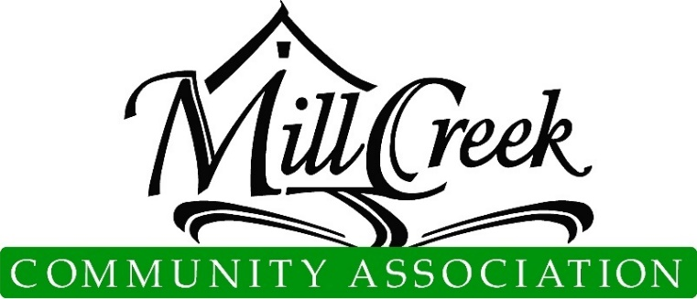
Architectural Control Committee

Plan and Specification Review Determination

PATIO, DECK, A/C, HOT TUB APPLICATION (page 1 of 3)
  - ACC approval includes aesthetic features only and does not imply or warrant any structural integrity. This approval is not based on an engineering review of the site plan or structure. Please note: You may need the City of Mill Creek’s permit and/or approval (425) 551-7254.
  - For MCCA Use Only
Submittal Number

Date Submitted

Please Attach Color Samples Here
Applications without samples will not be accepted.

Property owners are responsible for determining all property lines, locations, and related easements

Application may be mailed, emailed (info@mcca.info), or dropped off at the MCCA Office (15524 Country Club Dr, Mill Creek, WA 98012)
Applicant Information
Name |  | Ph.
Email
Site Information
Address
Division |  | Lot #
Type of Structure
Patio [ ] Deck [ ] A/C Unit [ ] Hot tub [ ]
Est. Start Date: | Est. End Date:
You must attach a diagram, picture, or brochure of the proposed unit and show the exact location of the unit relative to your home and property lines.

Pursuant to the provision of Article VIII, paragraphs 8.1, 8.2, 8.2.1, 8.2.2, 8.2.3, 8.3, 8.3.1, 8.3.2, and 8.3.3 and Article IX of the Mill Creek Declaration of Covenants, the following determination by the Architectural Control Committee is hereby granted:
Approval subject to the following changes:

Rejected for the following reasons:

( ) Approve | ( ) Reject | Date:  Condominiums & Townhomes ACC or Board Approval
( ) Approve | ( ) Reject | Date:  MCCA Administration
( ) Approve | ( ) Reject | Date:  Chair, Architectural Control Committee
( ) Approve | ( ) Reject | Date:
( ) Approve | ( ) Reject | Date:
( ) Approve | ( ) Reject | Date:

Architectural Control Committee

Plan and Specification Review Determination

PATIO, DECK, A/C, HOT TUB APPLICATION (page 2 of 3)

IMPORTANT: Include a sketch of the proposed fencing describing location on the property, dimensions and style (see item #1 of "Basic Policy for Additional Construction" on page 3). Attach additional sheets if needed.

Proposed Construction/Location Drawing (Property sketch):

Architectural Control Committee

Plan and Specification Review Determination

PATIO, DECK, A/C, HOT TUB APPLICATION (page 3 of 3)
Basic Policy for Additional Construction
**ALSO SEE THE ACC GUIDELINES**
Any additional construction upon a building site must be submitted to and approved by the Architectural Control Committee prior to commencement. In the event approval has not been received, a "Stop Work Order" will be issued until such time as the property paperwork has been received and processed by the MCCA office. As part of the submittal procedure, the following information must be furnished to the ACC before the submittal is acted on:
- Detailed information, written or printed, on type of addition that is planned for the site. This information should include exact location, finished dimensions, color, style, materials, etc.
- An elevation drawing or a perspective drawing of the proposed additional construction sufficiently detailed to show the appearance of the addition and its relationship to the existing structure.
- A sketch of the property showing the relationship between the proposed addition and all other adjacent structures. It is the homeowner's responsibility to locate and identify all property markers, both at the site and on the sketch included with the submittal.
- As a matter of record, a projected completion date is requested by the owner. If any extension of the completion date is necessary, or the project is canceled/postponed, the Association Office should be notified.
- Approved plans are subject to final inspection if deemed necessary by the Committee. All plans become the property of the Association and will be filed in the lot file. In case of changes, plans should be resubmitted to the Committee prior to construction. Variance from approved plans may be subject to change at the homeowner's expense or removal at the discretion of the Committee.

This signature verifies that the applicant has reviewed the above policy and agrees to abide by all guidelines and terms of approval set forth on the application attached. Signature also implies "Right of Entry" for members of the ACC for the purpose of plan review.

Applicant Signature Date

☐Owner Requests ACC Members Call Before Entering Property For Review (discuss specifics of project, pet in yard,
children at home alone, etc. )

