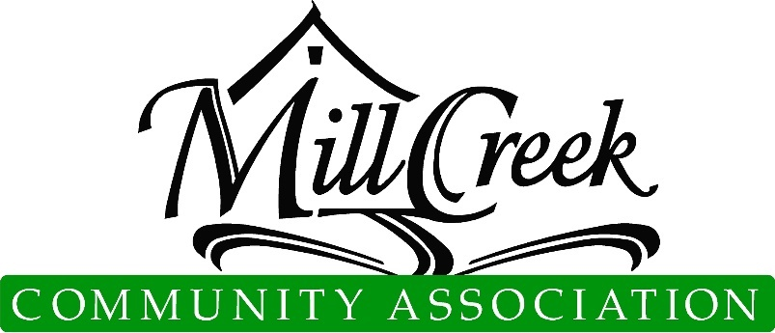
Architectural Control Committee Page 1 of 3

Plan and Specification Review Determination

TREE TRIM / REMOVAL APPLICATION
  - ACC approval includes aesthetic features only and does not imply or warrant any structural integrity. This approval is not based on an engineering review of the site plan or structure. Please note: You may need the City of Mill Creek’s approval www.cityofmillcreek.com. .
  - For MCCA Use Only
Submittal Number

Date Submitted

Inspection Notes

Application may be mailed, emailed (info@mcca.info), or dropped off at the MCCA Office (15524 Country Club Dr, Mill Creek, WA 98012)
Applicant Information
Name: |  | Ph.
Email:
Address:
Site Information
Division: |  | Lot #:
Tree Information
Types of Trees
# Removed
# Trimmed
Tree Replacement Information
# Replacements
Type of Trees

Pursuant to the provision of Article VIII, paragraphs 8.1, 8.2, 8.2.1, 8.2.2, 8.2.3, 8.3, 8.3.1, 8.3.2, and 8.3.3 and Article IX of the Mill Creek Declaration of Covenants, the following determination by the Architectural Control Committee is hereby granted:
Approval subject to the following changes:

Rejected for the following reasons:

( ) Approve | ( ) Reject | Date:  Condominiums & Townhomes ACC or Board Approval
( ) Approve | ( ) Reject | Date:  MCCA Administration
( ) Approve | ( ) Reject | Date:  Chair, Architectural Control Committee
( ) Approve | ( ) Reject | Date:
( ) Approve | ( ) Reject | Date:
( ) Approve | ( ) Reject | Date:

. Architectural Control Committee Page 2 of 3

Plan and Specification Review Determination

TREE TRIM / REMOVAL APPLICATION
MCCA requires the replacement of trees as follows: “In cases of approved removal, the Association requires replacement on a 1-1 ratio with trees in 1 gallon sized pots; unapproved removal will require replacement on a 2-1 ratio. Replacements are to be planted on private property or other locations determined by ACC. Removal of native evergreens will require replacement with native evergreens. You may need the City of Mill Creek's approval for any native tree. If the tree is considered a “Street Tree” by the city, we will require a copy of your approved permit with the City of Mill Creek to review your application. www.cityofmillcreek.com.
IMPORTANT: Please include a sketch of the property below showing the exact location of the proposed tree(s) to be cut. Mark trees to be considered for removal.
Proposed Tree Cutting (sketch):
Show proposed tree replacement(s), including type of tree(s). (sketch):
ACC Notes

Architectural Control Committee Page 3 of 3

Plan and Specification Review Determination

TREE TRIM / REMOVAL APPLICATION

Basic Policy for Tree Trimming / Removal Permits
Policies
- With regard to trees in cutting preserves and common property, no tree will be removed unless a particular problem exists, or the tree is dead. Approval is required, as outlined in Item 2 listed below. MCCA will remove those identified trees on MCCA property.
- Native evergreens/firs will not be removed unless said trees are dead or pose a threat to property. Homeowners must provide an arborist report, if required. In the event an arborist opinion is required, the submittal will be placed in abeyance and the thirty-day clause voided.
- Trees to be considered for removal, must be marked so they are easily identified by the committee.
- The approved permit application must be on-site during the tree removal process.
- Limbs and tree rounds must be removed. If cordwood is kept, it must be stored out of view.
- Stump must be removed or dealt with appropriately.
Procedure
- Homeowner submits application, marks the trees to be cut, and MCCA suggests contacting adjoining property owners.
- Committee inspects trees. If necessary, can require the applicant to provide an arborist report.
- Application is approved or denied and the homeowner is notified.
- Homeowner cuts trees, disposes of limbs and rounds. Replacement trees must be planted, if required.

Applicant Signature Date
☐Owner requests ACC Members call before entering the property for inspections or discussion of project specifics.

