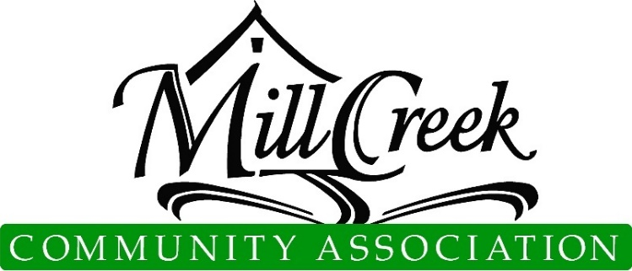
Architectural Control Committee

Plan and Specification Review Determination

Temporary Storage/Dumpster Application
  - ACC approval includes aesthetic features only and does not imply or warrant any structural integrity. This approval is not based on an engineering review of the site plan or structure. Please note: Roofing requires a City of Mill Creek permit (425) 551-7254.
  - For MCCA Use Only
Submittal Number

Date Submitted

Property owners are responsible for determining all property lines, locations, and related easements

Application may be mailed, emailed (info@mcca.info), or dropped off at the MCCA Office (15524 Country Club Dr, Mill Creek, WA 98012)
Applicant Information
Name |  | Ph.
Email
Site Information
Address
Division |  | Lot #
Container Information
Type:
Purpose of Temporary Storage/Dumpster:
Est. Delivery Date: | Est. Haul Date:

Pursuant to the provision of Article VIII, paragraphs 8.1, 8.2, 8.2.1, 8.2.2, 8.2.3, 8.3, 8.3.1, 8.3.2, and 8.3.3 and Article IX of the Mill Creek Declaration of Covenants, the following determination by the Architectural Control Committee is hereby granted:
Approval subject to the following changes:

Rejected for the following reasons:

( ) Approve | ( ) Reject | Date:  Condominiums & Townhomes ACC or Board Approval
( ) Approve | ( ) Reject | Date:  MCCA Administration
( ) Approve | ( ) Reject | Date:  Chair, Architectural Control Committee
( ) Approve | ( ) Reject | Date:

Applicant Signature Date

☐Owner Requests ACC Members Call Before Entering Property For Review (discuss specifics of project, pet in yard,
children at home alone, etc.

