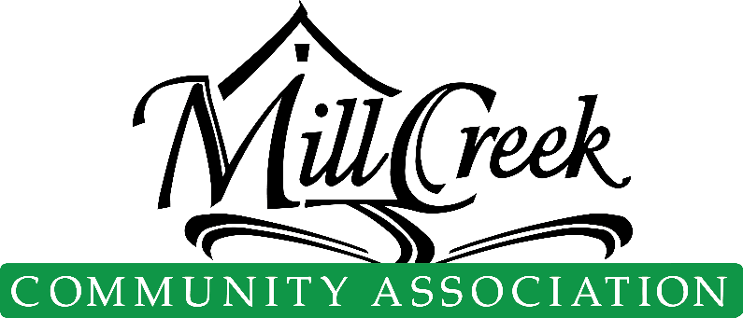

COVENANT ENFORCEMENT REQUEST FORM

Email completed form to: compliance@info.mcca
Complaint Submission Date
Information regarding the alleged resident in violation of MCCA Covenant
Name
Address
Division |  |  |  | Lot #
A detailed description of the alleged violation
Please be assured that the information below is kept confidential. However, your name and contact information are required to ensure that you are a resident of MCCA. We may use this information to contact you if additional information regarding the alleged violation is required. Anonymous complaints will not be processed.

Your Name
Your Email Address
Your Home Address
Your Phone Number
Click here to access the MCCA Governing Documents

